Trinity College Chemical Hygiene Plan

**Table of contents**

**Occupational exposure to hazardous chemicals in laboratories: Chemical Hygiene Plan outline**

1. Trinity College’s Commitment to safety
   1. Purpose
   2. Scope
   3. Location and Type of Laboratories Covered by Chemical Hygiene Plan
2. Roles and Responsibilities for the Chemical Hygiene Plan
   1. Administrative and Department assignments
   2. Trinity College Chemical Hygiene Committee
   3. Trinity College Responsibilities
   4. Responsibilities of Chemical Hygiene Officer
   5. Responsibilities of Associate Chemical Hygiene Officers
   6. Responsibilities of Laboratory Supervisors
   7. Responsibilities of all Lab Personnel
3. Hazard Communication and Identification
   1. General
   2. National Fire Protection Associated (NFPA) 704 Rating System
   3. Hazardous Materials Identification System
4. Health and Safety Information Related to the Types of Chemicals which may be found in Trinity College Laboratories
   1. Flammable and Combustibles
   2. Compressed Gases
   3. Cryogenics
   4. Asphyxiants
   5. Toxic Chemicals
   6. Particularly Hazardous Substances
   7. Reactive Chemicals
   8. Water Reactive Chemicals
   9. Pyrophoric Chemicals
   10. Organic Peroxides
   11. Peroxide Formers
   12. Self-Reactive Chemicals
   13. Corrosive Chemicals
   14. Oxidizers
   15. Dry Ice
5. Minimizing and Controlling Exposure to Hazardous Chemicals
   1. General
   2. Hazard Identification and Communication
   3. Hazard Assessments
   4. Routes of Exposure
   5. Exposure Controls
   6. Standard Operating Procedures
   7. Training
6. Standard Operating Procedures for Working in Laboratories
   1. Proper Laboratory Attire
   2. Personal Protective Equipment (PPE)
   3. General Safety Guidelines
   4. Housekeeping
   5. Personal Hygiene
   6. Chemical Safety Information Sources
   7. Chemical Procurement and Screening
   8. General Chemical Storage and Handling Guidelines
   9. Work in Chemical Fume Hoods
   10. Equipment containing radiation hazards, sealed sources or lasers
   11. Increases in Chemical Hazard or Biological Materials
7. Safety and Emergency Equipment in Laboratories
   1. General
   2. Fume Hoods/Ventilation
   3. Safety Showers and Eyewash Facilities
   4. Spill Kits
   5. Fire Extinguishers
   6. First Aid Kits
8. Emergency Procedures
   1. Chemical Spills- General
   2. Chemical Spills -Minor Spill Events
   3. Chemical Spill- Major (Emergency) Spill Events
   4. Hazardous Materials Exposures- Guidelines
   5. Medical Consultation
9. Laboratory Waste Management
   1. Introduction
   2. General Laboratory Waste Guidelines
   3. Guidelines for Storage and Handling of Hazardous Waste
   4. Biological Waste
10. Information and Training
    1. General
    2. Training Program Overview
11. Inspection and Plan Evaluation
    1. Laboratory Inspections
    2. Plan Review and Update
12. Records and Retention
    1. Records to be Maintained
    2. Records Retention
13. Associated Documents
14. Document Review and Revision History
15. **Trinity College’s Commitment to Safety**

Trinity College is committed to providing a safe working environment for both its students and employees. Trinity believes that employees and students have a right to know about the health hazards associated with their duties.

The College Administration has the responsibility to adopt policies and procedures that minimize exposure of employees to hazardous chemicals present in college laboratories. It has the further responsibility to provide information and appropriate training to make employees aware of potential hazards and safe working practices. The Chemical Hygiene Plan is the document that specifies how these responsibilities will be discharged.

Employees have the responsibility to participate actively in training programs, to know and follow the policies and procedures contained in the Chemical Hygiene Plan, and to conduct their work activities in a manner which minimizes their risk of exposure. Because the people who work in any given laboratory are best able to detect potential hazards in either the facility or in the work procedures, when safety concerns arise, employees are encouraged to discuss their concerns with their principal investigator or supervisor for communication to the proper administrative authority.

* 1. **Purpose**

The purpose of the Chemical Hygiene Plan (CHP) is to provide guidance to college laboratory personnel for working safely in the laboratory environment. The CHP complies with the requirements of OSHA's Laboratory Standard and describes proper laboratory practices, procedures, protective equipment and hazard identification. The CHP is available within the Environmental Health and Safety Office, main offices of Biology, Art and Chemistry and online at the EHS webpage. A copy of the CHP should be maintained with or in the Safety Data Sheet (SDS) binder and be readily available to all personnel in the laboratory

* 1. **Scope**

The provisions of the CHP apply to all Trinity laboratory personnel, other employees who routinely visit or occasionally work in the laboratory and all contractors who might be exposed to laboratory hazards while on campus. All laboratory personnel are encouraged to contribute their skills and knowledge to the CHP such as routine activities, chemical safety, hazardous material handling or procedures to minimize chemical exposures.

Advice will be sought from the campus community as to the effectiveness of the plan at least annually. All new laboratory personnel will be required to review and understand the CHP as part of their New Employee Orientation and all laboratory personnel will receive annual CHP training

* 1. **Location and Type of Laboratories Covered by Chemical Hygiene Plan**

| **Building** | **Discipline(s)** | **Lab Rooms** |
| --- | --- | --- |
| Clement Chemistry | General/Intro Chemistry;  Analytical Chemistry;  Inorganic Chemistry;  Organic Chemistry;  Physical Chemistry | All teaching and research labs located on the first, second and third floor. |
| Jacobs Life Sciences Center | Introductory Biology  Plant Biology  Cell and Molecular Biology  Biochemistry Neuroscience | All teaching and research labs located in the basement, first, second and third floors. |
| MCEC | Electrophysiology  Biomedical Engineering | Rm. 376 |
| McCook | Condensed Matter Physics  Semiconductor Engineering  Chemical Storage Room | Rm. 115  Rm. 108  Rm. 221 |
| Austin Arts Center | Studio Arts  Printmaking | Rm. 325 |
| CCAN | Neuroscience | Rm. 103 |

1. **Roles and Responsibilities for the Chemical Hygiene Plan**
   1. **Administrative and Department Assignments**

* College President – Joanne Berger-Sweeney
* Dean of Faculty – Sonia Cardenas
* College Chemical Hygiene Officer – Kyle Coughlin
* Associate Chemical Hygiene Officer – Erin Mostoller
* Associate Chemical Hygiene Officer – Jim McLaren
  1. **Trinity College Chemical Hygiene Committee**

The Trinity College Laboratory and Shop Safety Committee (LSSC) is a cross-departmental team which fulfills the function of the Chemical Hygiene Committee as a subset of its duties, as the committee is primarily comprised of representatives from the departments in which this Chemical Hygiene Plan (CHP) directly covers. The committee is responsible for assuring the continued implementation, review, and improvement of the CHP. The Laboratory and Shop Safety Committee serves as an advisory board to the Chemical Hygiene Officer in formulating policies and procedures relating to the CHP. Members of this committee are also tasked with communicating updates and useful information from the committee to their respected departments.

The LSCC is chaired by the college’s EHS Manager. Each meeting, which occurs quarterly, has the direct task of reviewing CHP policy and incident reports. The goal of this committee is to continually improve the laboratory procedures so we can ensure continued improvement in safety initiatives at Trinity College. Meeting minutes are kept and stored in the EHS office. These minutes are available upon request.

Current members of the Committee:

* EHS Manager / College CHO – Kyle Coughlin
* Chemistry Lab Technician / Associate CHO – Jim McLaren
* Biology Lab Manager / Associate CHO – Erin Mostoller
* Engineering Technician – Andrew Musulin
  1. **Trinity College Responsibilities**

Trinity College has an ethical and legal obligation assure chemical health and safety at all levels. This includes (but is not limited to) the following specific roles:

1. College President – Ultimately responsible for chemical safety on campus; with the administration, must provide support for implementation and maintenance of the Chemical Hygiene Plan.
2. Dean of Faculty/Department Heads – Responsible for implementation and execution of the Chemical Hygiene Plan within their respective departments/units.
3. Principal Investigators/Faculty – Responsible for implementation and execution of the Chemical Hygiene Plan within the laboratories assigned to them. These personnel must have current knowledge of the chemicals stored and used/handled in their laboratories, including their hazards and how to control exposure through proper selection and use of engineering controls, laboratory work practices, and personal protective equipment.
   1. **College Chemical Hygiene Officer (CHO) Responsibilities** 
      1. Develop, maintain, and update the Chemical Hygiene Plan (CHP);
      2. Provide technical direction and guidance to Lab Supervisors and Lab Personnel pertaining to the implementation and execution of the CHP within their areas of expertise;
      3. Understand and manage specific regulatory requirements pertaining to chemical safety and hygiene;
      4. Monitor and record procurement of new chemicals;
      5. Gather and maintain manufacturer SDS’s;
      6. Review chemical inventory regularly and report any chemicals which are highly toxic or carcinogenic;
      7. Monitor collection and disposal of chemical wastes;
      8. Coordinate training of laboratory personnel;
      9. Maintain records of laboratory incidents, training and medical consultations;
      10. Review and purchase the use of particularly hazardous substances; ensure that affected personnel are trained in the use of the chemical(s);
      11. Conduct regular laboratory safety audits and inspections. Report results and recommendations to the laboratory supervisor;
      12. Maintain and facilitate implementation of the respirator Respiratory Protection Program;
      13. Coordinate and oversee the annual fume hood certification program;
      14. Facilitate Lab Safety Training;
      15. Oversee Incident Investigations;
      16. Perform hazard assessments for lab activities; and
      17. Work with lab supervisors and personnel to address unsafe or out of compliance issues.
   2. **Associate Chemical Hygiene Officer Responsibilities** 
      1. Monitor and record procurement of new chemicals
      2. Gather and maintain manufacturer SDS’s
      3. Develop, maintain, and update the Chemical Hygiene Plan (CHP);
      4. Review chemical inventory regularly and report any chemicals which are highly toxic or carcinogenic;
      5. Review and purchase the use of particularly hazardous substances; ensure that affected personnel are trained in the use of the chemical(s);
      6. Remove laboratory waste from their departments and manage the Main Accumulation Area (MAA);
      7. Conduct regular laboratory safety audits and inspections. Report results and recommendations to the laboratory supervisor;
      8. Oversee incident investigations; and
      9. Work with lab supervisors and personnel to address unsafe or out of compliance issues.
   3. **Responsibilities of Laboratory Supervisors**

Laboratory Supervisors are faculty and administrative staff who supervise personnel in research or teaching laboratories. Laboratory supervisors have the actual hands-on responsibility for implementing the chemical hygiene plan. Their responsibilities include the following:

1. Ensure that the CHP is available and has been explained to the other employees in their laboratory;
2. Assure that chemical hazards have been evaluated and are understood;
3. Assure that chemical hazards are managed through engineering controls, laboratory work practices, and personal protective equipment (PPE);
4. Ensure that PPE requirements are clearly established, and appropriate PPE is available for use as needed;
5. Inform personnel working in the laboratory (students, faculty, staff, visitors) of the potential hazards associated with the use of chemicals in the laboratory and instructing them in the safe laboratory practices, adequate controls, and procedures for dealing with accidents involving hazardous chemicals;
6. Assure all personnel within area(s) of responsibility complete the requisite laboratory safety training.
7. Supervise lab operations and enforce safety requirements in accordance with this CHP;
8. Routinely monitor for proper functioning of laboratory fume hoods and other safety equipment and arrange for prompt repairs when deficiencies are identified;
9. Perform regular chemical hygiene and housekeeping inspections within area(s) of responsibility.
10. Assure that all chemical containers are properly labeled as detailed in this CHP.
11. Promptly report any incident to overexposure of chemicals to Chemical Hygiene Officer (CHO) and assist with completion of an incident investigation.
12. Promptly notify and work with the CHO to correct unsafe conditions when identified.
13. Ensure that all chemicals are properly stored.
    1. **Responsibilities of All Laboratory Personnel (Faculty, Staff, and Students)**

Each person working with or around chemicals of any kind, having been trained, is responsible for remaining aware of the hazards of those materials and handling them in a safe manner, in accordance to the Chemical Hygiene Plan. This general responsibility is support by fulfilling following specific responsibilities:

* Review, understand, and follow the policies and procedures outlined in the CHP;
* Complete required lab safety training;
* Plan and conduct each operation in accordance with the CHP; and, when required, obtaining prior approval from the Chemical Hygiene Officer;
* Wear appropriate personal protective equipment and following safe work practices as outlined in the CHP;
* Assure that all chemicals are properly labeled and stored in accordance with the procedures set forth in this CHP;
* Collect, label, and store hazardous waste properly;
* Immediately report unsafe conditions to the Lab Supervisor and/or CHO; and
* Immediately report incidents to the Lab Supervisor and/or CHO

1. **Hazard Communication and Identification**
   1. **General**

This section provides an outline of the two most common systems that chemical manufacturers use to communicate product hazards and their general requirements:

1. Global Harmonization System (GHS); and
2. National Fire Protection Association (NFPA).

This section will also outline Trinity College’s labeling policy for secondary containers (i.e. vessels that contain chemical mixtures for laboratory use) using the Hazardous Materials Information System (HMIS);

* 1. **Globally Harmonized System**

1. General

The Global Harmonization System (GHS) is a worldwide system adopted by OSHA to standardize and harmonize the classification and labeling of chemicals. Employees will find GHS pictograms and standardized information on SDSs and chemical containers acquired from manufacturers. The objectives of GHS are to:

* 1. Define the health, physical, and environmental hazards of chemicals;
  2. Create classification processes that use available data on chemicals for comparison with the defined hazard criteria; and
  3. Communicate hazard information and protective measures on labels and SDSs.

1. Product Labels

The GHS standardized label elements, which are not subject to variation and must appear on every chemical label, contain the following elements (See sample image label provided below):

1. 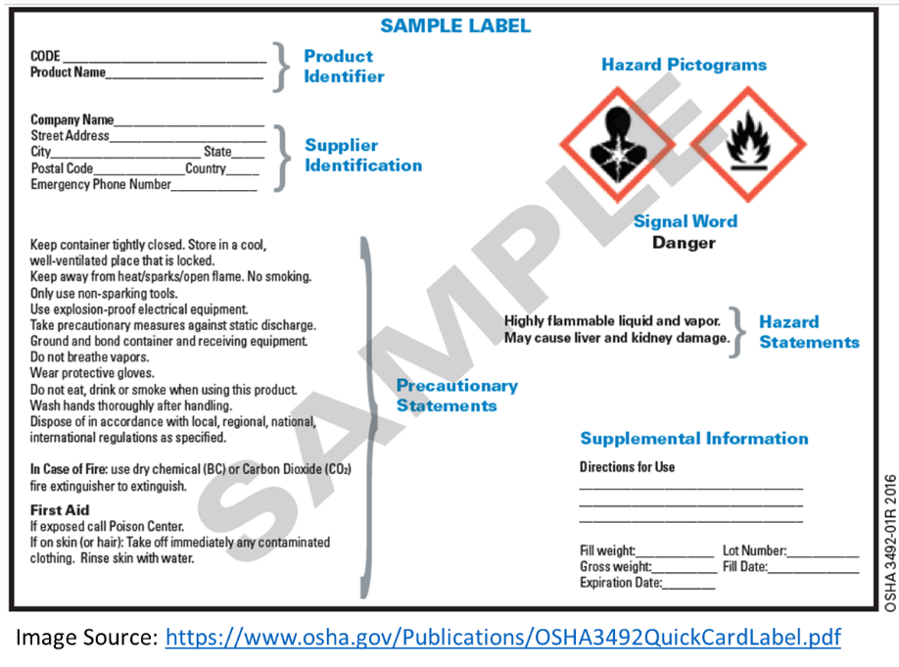Product Identifier: The name or number used for a hazardous chemical on a label or in the SDS. It provides a unique means by which the user can identify the chemical.
2. Hazard Pictogram: Used to convey health, physical, and environmental hazard information for an assigned GHS hazard class and category;
3. Signal Words: such as “DANGER” (for more severe hazards) or “WARNING” (for less severe hazards), are used to emphasize hazards and indicate the relative level of severity of the hazard assigned to a GHS hazard class and category.
4. Hazard Statement(s): Standardized phrases assigned to a hazard class and category that describe the nature of the hazard (e.g. Danger, Extremely Flammable Liquid, and Vapor, etc.); and
5. Precautionary Statement(s): Recommended measures that should be taken to minimize or prevent adverse effects resulting from exposure to the hazardous chemical.

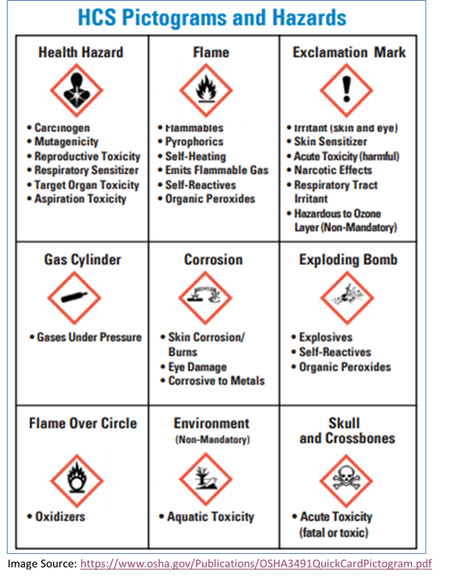GHS also standardizes the hazard pictograms that are used on all hazard labels and SDSs. There are 9 pictograms that represent several defined hazards and include the harmonized hazard symbols that are intended to convey specific information about each hazard. GHS labeling requirements are only applicable to chemical manufacturer, distributers, and shippers of chemicals. Each pictogram consists of a symbol on a white background framed within a red border and represents a distinct hazard(s). The pictogram on the label is determined by the chemical hazard classification.

GHS labeling is not required for laboratory chemicals stored in secondary containment. However, since most chemicals stored in the lab have been purchased from a chemical manufacturer, the GHS requirements are very relevant and should be understood by lab personnel.

1. Safety Data Sheets (SDSs)

SDSs are documents created by the chemical manufacturer that describe a chemical substance. GHS has standardized SDS requirements and format. SDSs are required for all hazardous chemicals onsite and shall remain on file for 30 years after employment. Laboratory personnel must review an SDS for information about hazards, and safety precautions before working with a new chemical. The following information is required by OSHA to be included in all SDSs:

Section 1: Identification

Section 2: Hazard(s) Identification

Section 3: Composition / Information on Constituents

Section 4: First-Aid Measures

Section 5: Fire-Fighting Measures

Section 6: Accidental Release Measures

Section 7: Handling & Storage

Section 8: Exposure Controls / Personal Protection

Section 9: Physical & Chemical Properties

Section 10: Stability & Reactivity

Section 11: Toxicological Information

Section 12: Ecological Information (non-mandatory)

Section 13: Disposal Considerations (non-mandatory)

Section 14: Transportation Information (non-mandatory)

Section 15: Regulatory Information (non-mandatory)

Section 16: Other

An SDS for each chemical in the Trinity College inventory can be found in the Vertere Chemical Inventory System. The Lab Manager for each Department is responsible for uploading digital copies to the database as new chemicals come in.

* 1. **National Fire Protection Association (NFPA) 704 Rating System**

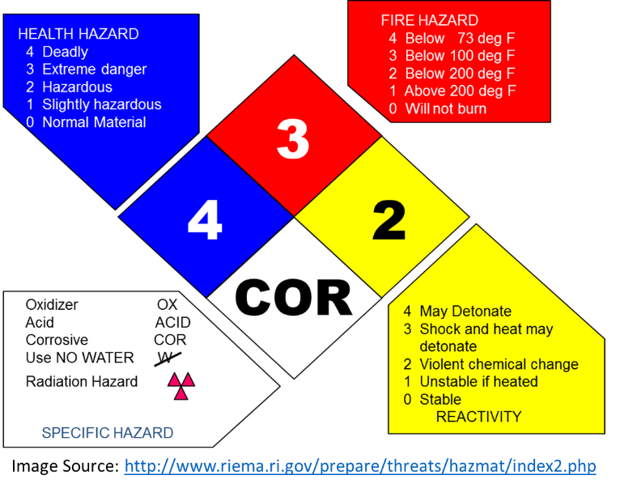The National Fire Protections Association’s 704 System is a standardized system that utilizes numbers and colors on a sign to indicate the basic hazards of a specific material being stored in large containers.

The hazard identification signal is a color-coded array of four numbers or letters arranged in a diamond shape. You will see hazard diamonds, like the one shown below, on trucks, storage tanks, bottles of chemicals, and in other various places. The blue, red, and yellow fields represent health, flammability, and reactivity, respectively. Each uses a numbering scale ranging from 0 to 4. A value of zero means that the material poses essentially no hazard; a rating of four indicates extreme danger. The fourth value (associated with white) tends to be more variable, both in meaning and in what letters or numbers are written there.

* 1. **Hazardous Materials Identification System**

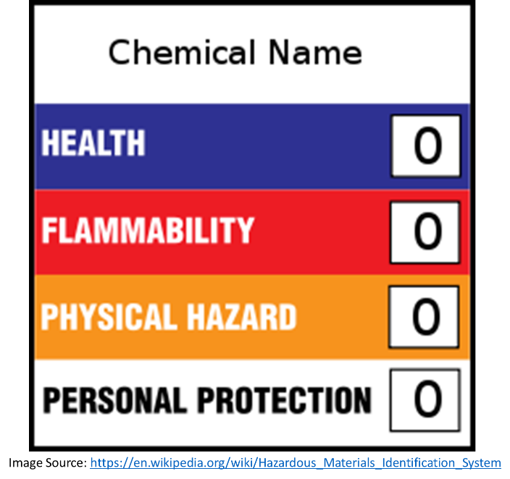HMIS® was developed by a American Coatings Association to help employers comply with the Hazard Communication Standard. The system uses colored bars, numbers and symbols to convey the hazards of chemicals used in the workplace. The system defines hazard categories (Health, Flammability and Reactivity) and rates each on a scale of 0-4, where 0 represents no hazard and 4 represents the highest hazard rating. This numbering system aligns with the NFPA rating system defined above.

1. **Health and Safety Information Related to the Types of Chemicals Which may be Found in Trinity College Laboratories**
   1. **Flammable and Combustible Liquids**

The two primary hazards associated with flammable and combustible liquids are explosion and fire. Flammable liquids are particularly hazardous due to their ability to produce vapors. This vapor mixes with air and burns quickly when the flammable liquid is heated to its flashpoint or above and is ignited. While there is a technical distinction between “flammable” and “combustible” liquids, both burn readily and intensively, are explosive under certain conditions, and if not properly contained can spread fire rapidly and uncontrollably. Safe handling and storage of flammable and combustible liquids require the use of appropriate equipment and practices.

1. Definitions and Classes of Flammable and Combustible Liquids [Per NFPA: *30 Flammable and Combustible Liquids Code*]
   1. Flammable Liquids – Liquids having closed cup flash points below 100°F (37°C) and vapor pressures not exceeding 40 psi (276 kPa) (2.76 bar) at 100°F (37°C). Flammable liquids are referred to as Class 1 liquids.
      1. Class IA liquids – flash points below 73°F (22.8°C) and boiling points below 100°F (37.8°C).
      2. Class IB liquids – flash points below 73°F (22.8°C) and boiling points at or above 100°F (37.8°C).
      3. Class IC liquids – flash points at or above 73°F (22.8°C) and below 100°F (37.8°C).
   2. Combustible Liquids - Liquids having closed cup flash points at or above 100°F (37°C). Combustible liquids are referred to as Class II or Class III liquids.
      1. Class II liquids – flash points at or above 100°F (37.8°C) and below 140°F (60°C).
      2. Class IIIA liquids – flash points at or above 140°F (60°C) and below 200°F (93.4°C). Class IIIB liquids – flash points at or above 200°F (93.4°C).
2. Properties and NFPA Classification of Common Laboratory Chemicals

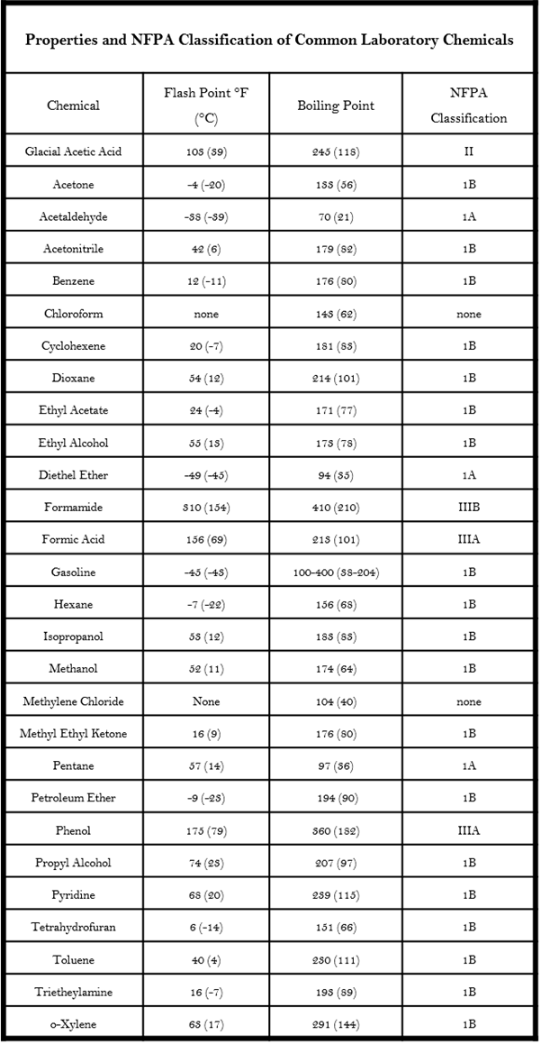

1. Safety Precautions

Fire requires three very specific ingredients in order to burn:

* Oxygen (in sufficient concentration to sustain combustion)
* Fuel Source (the flammable or combustible material)
* Heat (sufficient to raise the fuel source to its ignition temperature)

Without the presence of all of these ingredients, a fire cannot start. Remove even one of these ingredients and a fire cannot continue to burn. Our intention is to:

* 1. Use, handle, and store flammable and combustible materials in a manner which does not allow for all three specific fire ingredients to be present together or to sustain a prolonged, widespread fire event; and
  2. Minimize the threat to persons and property by implementing emergency procedures to be utilized if a fire event were to occur.

To that end, the following precautionary measures must be observed by all laboratory personnel in all laboratories where flammable and combustible liquids are used, handled, and/or stored:

1. Smoking or other sources of open flames are prohibited in any/all lab spaces and other areas where flammable and combustible chemicals are present;
2. All lab personnel are expected to know the location fire extinguishers, fire alarms, and emergency exits in the laboratory;
3. Flammable and combustible liquids must not be stored in domestic-type refrigerators. Use only refrigerators rated for flammables;
4. Do not store flammables with oxidizing agents (e.g., nitric and sulfuric acids;
5. Do not expose flammable liquids to potential sources of ignition such as electrical equipment, heat, burners, or open flames;
6. To prevent accidental electrical charge during pouring or dispensing, bonding and grounding equipment should be used whenever practicable. The use of non-sparking tools can prevent an ignition source;
7. Storage of flammable liquids greater than 10 gallons within a laboratory fire area must in an approved and labeled flammable storage cabinet. Lab personnel are expected to store all flammable liquids flammable storage cabinets when not in use; Flammable and combustible liquids must be stored in appropriate type/ size container and in accordance with the limits described in the tables below:

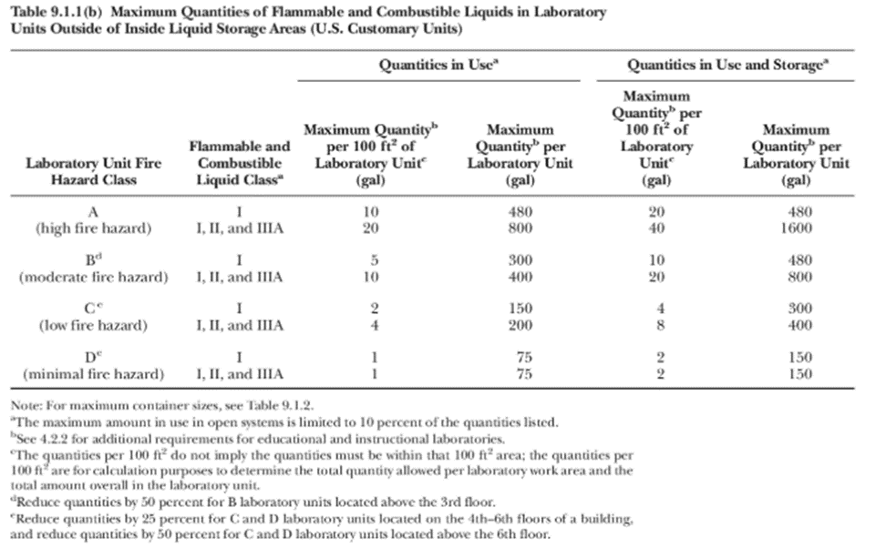

1. Do not store flammable liquids on the floor, unless protected by secondary containment;
2. Minimize the amount flammable liquids that are in use, being stored, and that are generated as wastes. Wastes which include flammable and combustible liquids must be managed in accordance with the waste procedures detailed in Section 4.2 of this CHP;
3. Fume hoods, or other approved locally exhausted ventilation, should be used whenever handling flammable liquids. Local exhaust ventilation is particularly important when using larger quantities (>500ml) or when flammables are heated or at increased pressure; and
4. The SDS shall be reviewed by the owner/user of the materials for additional safety requirements and precautions based upon specific lab work activities and conditions.
   1. **Compressed Gases**
5. Overview & Hazards

Compressed gas cylinders contain varying pressures of inert, toxic, flammable, oxidizing, corrosive, or combinations of gases. These cylinders can pose a variety of physical and/or health hazards, depending type of compressed gas in the cylinder and its pressure.

Physical damage to cylinders or failure of its parts (e.g. valves, regulators, etc.) can result in a violent release of pressure and fragmentation. Cylinders can also become flying projectiles when cylinder valves are damaged or broken off.

Depending on the particular gas, there is a potential for simultaneous exposure to both mechanical and chemical hazards. Compressed gases can be:

* Flammable or combustible
* Corrosive
* Explosive
* Poisonous
* Inert (displace oxygen)
* Acidic
* Reactive
* or a combination of hazards

1. Safety Precautions

Appropriate care in the use, handling and storage of compressed gas cylinders is essential for the protection of people and property. As such, the following safety requirements must be implemented in all laboratories where compressed gasses are used, handled, and/or stored:

* 1. The cylinder contents must be clearly identifiable.
  2. Handle cylinders carefully and do not roll, slide, or drop. Use a cart or hand truck to transport.
  3. Do not lift a cylinder by its cap.
  4. Secure all cylinders while in storage, transport, or use.
  5. Never tamper with cylinder valves, force connections, or use homemade adapters. Use only approved equipment. Never repair or alter cylinders, valves, or safety relief devices.
  6. Only use a regulator compatible with the cylinder contents.
  7. Close the cylinder valve when not in use.
  8. When empty, turn off the cylinder valve and label the cylinder as empty. Store separately from full cylinders.
  9. Store cylinders in a well-ventilated area away from ignition sources, heat, flames, and flammable chemicals.
  10. Keep the protective caps on the cylinders at all times except when the cylinders are in active use.
  11. Do not store flammable gas cylinders with oxidizers such as nitrous oxide or oxygen. They must be separated by a minimum of 20 ft. or a 5-foot fire wall.
  12. Ensure the cylinder is labeled with “FULL”, “EMPTY”, OR “IN USE”
  13. **Cryogenics**

1. Overview & Hazards

A cryogenic liquid is defined as a liquid with a normal boiling point below -240°F (-150°C, 123°K). The most commonly used industrial gases that are transported, handled, and stored in the liquid state at cryogenic temperatures are argon, helium, hydrogen, nitrogen, and oxygen.

Many of the hazard and safety precautions observed for compressed gases also apply to cryogenic liquids. Two additional hazards are created from the unique properties of cryogenic liquids:

* Extremely Low Temperatures – Can produce cryogenic burns of the skin and freeze underlying tissue if contact occurs.
* Brittleization – Most metals become stronger upon exposure to cold temperatures, but materials such as carbon steel, plastics and rubber become brittle or even fracture under stress at these temperatures. Proper material selection is important. Cold burns and frostbite caused by cryogenic liquids can result in extensive tissue damage.
* Vaporization – all cryogenic liquids produce large volumes of gas when they vaporize (for example, liquid nitrogen will expand 696 times as it vaporizes).
  + If these liquids vaporize in a sealed container, they can produce enormous pressures that could rupture the vessel. For this reason, pressurized cryogenic containers are usually protected with multiple pressure relief devices.
  + Vaporization of cryogenic liquids (except oxygen) in an enclosed area can cause asphyxiation.
  + Vaporization of liquid oxygen can produce an oxygen-rich atmosphere, which will support and accelerate the combustion of other materials.
  + Vaporization of liquid hydrogen can form an extremely flammable mixture with air.

1. Safety Precautions

The safe handling of cryogenic liquids involves understanding the unique properties of these materials and ensuring that appropriate safety precautions are taken at all times. These safety precautions include, but are not limited to the following:

* 1. Cryogenic liquids should be handled and stored in well-ventilated areas;
  2. Handle the liquid slowly to minimize boiling and splashing. Use tongs to withdraw objects immersed in a cryogenic liquid - Boiling and splashing always occur when charging or filling a warm container with cryogenic liquid or when inserting objects into these liquids;
  3. Do not transport cryogenic liquids in wide-mouthed glass Dewars or Dewars not protected with safety tape;
  4. Use only approved containers. Impact resistant containers that can withstand the extremely low temperatures should be used. Materials such as carbon steel, plastic and rubber become brittle at these temperatures;
  5. Only store cryogenic materials in containers with loose fitting lids (Never seal liquid nitrogen in a container). A tightly sealed container will build up pressure as the liquid boils and may explode after a short time.
  6. Never touch non-insulated vessels containing cryogenic liquids. Flesh will stick to extremely cold materials. Even nonmetallic materials are dangerous to touch at low temperatures.
  7. Never tamper or modify safety devices such as cylinder valve or regulator of the tank.
  8. Liquid nitrogen should only be stored in well-ventilated areas (do not store in a confined space).
  9. Do not store liquid nitrogen for long periods in an uncovered container.

Cylinders and Dewars should not be filled to more than 80% of capacity, since expansion of gases during warming may cause excessive pressure buildup.

* 1. **Asphyxiants**

1. Overview & Hazards

Asphyxiants are substances that interfere with the transport of an adequate supply of oxygen to the vital organs of the body. Simple asphyxiants are substances that displace oxygen from the air being breathed to such an extent that adverse effects result. Acetylene, carbon dioxide, argon, helium, ethane, nitrogen and methane are common asphyxiants. It is important to recognize that even chemically inert and biologically benign substances such as carbon monoxide can be extremely dangerous under certain circumstances.

1. Safety Precautions
2. Store and use asphyxiants in well-ventilated areas with a minimum of six air changes per hour. Closets and small rooms should be avoided to prevent displacement of oxygen.
3. If you are using large quantities, especially if the chemical you are using has no warning properties (such as odor), contact the Chemical Hygiene Officer (CHO) to determine if ventilation is sufficient.
4. If you are working with an asphyxiant that is supplied as a cryogenic liquid or solid, also refer to the safety guidelines for cryogenic materials detailed above.
5. If you are working with an asphyxiant that is supplied as a compressed gas, also refer to the safety guidelines for compressed for compressed gases detailed above.
   1. **Toxic Chemicals**
6. Overview & Hazards

Toxins affect particular target organs. Target Organ Effects: Chemically caused effects from exposure to a material on specific listed organs and systems such as liver, lungs, and central nervous system. Chemicals can have adverse effects - acute or chronic, on many different organs of the body as a result of exposure. A wide range and diversity of effects and hazards can be found in the workplace.

Toxic materials include carcinogens, reproductive toxins (teratogens, mutagens, etc.) and acutely hazardous materials. Toxic materials which are simultaneously hazardous because of another attribute (i.e. flammable, corrosive) should be evaluated to determine which is the most significant hazard and stored accordingly.

Lab personnel can be exposed to toxicity hazards through one or more *Routes of Entry* into the body:

* Inhalation: For most chemicals in the form of vapors, gases, mists, or particulates, inhalation is the major route of entry. Once inhaled, chemicals are either exhaled or deposited in the respiratory tract. If deposited, damage can occur through direct contact with tissue or the chemical may diffuse into the blood through the lung-blood interface. Upon contact with tissue in the upper respiratory tract or lungs, chemicals may cause health effects ranging from simple irritation to severe tissue destruction. Substances absorbed into the blood are circulated and distributed to organs that have an affinity for that particular chemical. Health effects can then occur in the organs, which are sensitive to the toxicant.
* Skin (or mucous membrane) absorption: Skin (dermal) contact can cause effects that are relatively innocuous such as redness or mild dermatitis; more severe effects include destruction of skin tissue or other debilitating conditions. Many chemicals can also cross the skin barrier and be absorbed into the blood system. Once absorbed, they may produce systemic damage to internal organs. The eyes are particularly sensitive to chemicals. Even a short exposure can cause severe effects to the eyes or the substance can be absorbed through the eyes and be transported to other parts of the body causing harmful effects.
* Ingestion: Chemicals that inadvertently get into the mouth and are swallowed do not generally harm the gastrointestinal tract itself unless they are irritating or corrosive. Chemicals that are insoluble in the fluids of the gastrointestinal tract (stomach, small, and large intestines) are generally excreted. Others that are soluble are absorbed through the lining of the gastrointestinal tract. They are then transported by the blood to internal organs where they can cause damage.
* Injection: Substances may enter the body if the skin is penetrated or punctured by contaminated objects. Effects can then occur as the substance is circulated in the blood and deposited in the target organs.

1. Safety Precautions

The following measures should be taken by researchers working with toxic chemicals:

1. Read the safety data sheet (SDS) for each toxic chemical prior to use.
2. Eliminate, substitute less toxic chemicals or reduce the quantities of toxic chemicals being used if possible.
3. Toxic materials should be opened and handled only within a functioning ventilation enclosure, such as a laboratory hood, unless alternate work practices can achieve an equal or greater level of personal protection.
4. Wear appropriate personal protective equipment for the specific chemical hazard.
5. Properly label all toxic chemicals.
6. Store toxic chemicals in tightly sealed containers away from incompatible materials.
7. Corrosive, toxic liquids should be stored below eye level.
8. Do not eat, drink, smoke, chew gum or apply cosmetics in areas where toxic chemicals are present.
9. Routes of Entry: Be mindful of the routes of entry as they relate to toxic materials.
   * Absorption through skin or mucous membranes: Use appropriate PPE including gloves goggles, chemical aprons etc. as required and/or needed.
   * Inhalation: Perform chemical manipulations involving toxic materials in fume hoods and/or where adequate ventilation exists. If respiratory protection is required, you must have received appropriate training, fit-testing and medical surveillance through the EHS Department first.
   * Ingestion: Practice appropriate hygiene in the laboratory. Wash your hands often; keep surfaces clean of chemical residue; never eat, drink or smoke in the laboratory.
10. Injection: Be mindful of broken glass and sharps hazards. Dispose of contaminated sharps/glass immediately to prevent cuts or punctures.
    1. **Particularly Hazardous Substances**
11. Overview & Hazards

The Occupational Safety and Health Administration (OSHA) Laboratory Standard requires that special handling procedures be employed for certain chemicals identified as “particularly hazardous substances.”

Particularly hazardous substances (PHS) include chemicals that are “select carcinogens, reproductive toxins, and chemicals that have a high degree of acute toxicity.”

In addition, many chemicals used (including novel chemicals that are synthesized) in research laboratories have not been tested explicitly for carcinogenic or toxic properties and must therefore be handled as “particularly hazardous substances” since their hazards are unknown.

***Carcinogens***

Carcinogens are particularly insidious toxins because they may have no immediate apparent harmful effects.

A chemical is a carcinogen if:

1. It has been evaluated by the International Agency for Research on Cancer (IARC), and found to be a carcinogen or potential carcinogen; or
2. It is listed as a carcinogen or potential carcinogen in the Annual Report on Carcinogens published by the National Toxicology Program (NTP) (latest edition); or
3. It is regulated by OSHA as a carcinogen.

***Acutely Toxic Chemicals***

Chemicals that are acutely toxic produce adverse health effects following oral or dermal administration of a single dose of a substance, multiple doses given within 24 hours, or an inhalation exposure of 4 hours.

Refer to 29 CFR 1910.1200, Appendix A, Table A.1.1 for specific categorization and classification of oral, dermal, and inhalation acute toxicity.

***Allergens and Sensitizers***

A chemical allergy is an adverse reaction by the immune system to a chemical. Allergic reactions result from previous sensitization to a chemical or a structurally similar chemical. Once sensitization occurs, allergic reactions can result from exposure to extremely low doses of the chemical.

Allergic reactions can be immediate, occurring a few minutes after an exposure. Anaphylactic shock is a severe immediate allergic reaction that can result in death if not treated quickly.

Allergic reactions can also be delayed, taking hours or even days to develop. It is important to recognize that a delayed chemical allergy can occur even some time after the chemical has been removed.

Examples of substances that may cause allergic reactions include diazomethane, formaldehyde, various isocyanates, benzylic and allylic halides and certain phenol derivatives.

***Unknowns***

Unknown chemicals, or those for which complete physical and chemical hazards are not known, must be assumed to be hazardous and highly toxic.

They should be handled with extreme caution and treated as highly toxic by inhalation, ingestion, and absorption.

As employees discover unknown chemicals, please report them to the CHO for proper analysis. Unknown chemicals shall not be opened by lab personnel, but rather transported to the chemical waste room in a sealed container within secondary containment.

1. Safety Precautions

The following guidelines must be followed with PHS’:

1. The PHS’s must be used and stored only in designated areas with restricted access.
2. Designated areas may be used for work with these materials and may be the entire laboratory, a glove box, an area of a laboratory, or a device such as a chemical fume hood.
3. The designated area must be clearly posted with signs that:
   * Identify the hazards;
   * Notify employees when the hazardous material is in use;
   * Restrict untrained personnel in the work area; and
   * Clearly define the designated area.
4. Only the smallest amount of a PHS required by the procedure shall be used or stored.
5. When possible only order the required amounts to avoid unnecessary decanting or weighing out the material.
6. All laboratory personnel working with these chemicals shall be familiar with the hazards and proper procedures for accidental release.
7. All laboratory personnel will be familiar with the signs and symptoms of exposure and know emergency procedures to follow in case of an exposure.
8. General PPE to be worn at all times when working with these materials are safety glasses, gloves, long sleeve laboratory coats, and no open toed shoes.
9. The designated work area shall always be decontaminated after each process, experiment, or when the work is completed.
10. All waste products from the process shall be managed in a compatible container, collected, and disposed of properly.
    1. **Reactive Chemicals**
11. Overview & Hazards

Reactive chemicals are those that, under certain conditions, release very large and potentially dangerous amounts of energy. Reaction rates almost always increase rapidly as the temperature increases. If the heat evolved in a reaction is not dissipated, the reaction rate can increase until an explosion results.

Air, light, heat, mechanical shock (when struck, vibrated or otherwise agitated), water, and certain catalysts can cause decomposition of some highly reactive chemicals, and initiate an explosive reaction. Hydrogen and chlorine react explosively in the presence of light. Alkali metals, such as sodium, potassium and lithium, react violently with water liberating hydrogen gas. Examples of shock sensitive materials include acetylides, azides, organic nitrates, nitro compounds, and many peroxides.

1. Safety Precautions

### The following safety considerations must be implemented when using, handling, and storing reactive materials:

#### Always review the safety data sheet for specific information regarding chemical instability and reactivity. Take into consideration the conditions to avoid, incompatible materials, and all other references to reactivity.

#### Additional PPE is required when using reactives, especially those with the potential for physical hazards.

#### Employees must review the Hazard Assessment prior to beginning work with reactive chemicals.

#### Reactive chemical use must be limited to designated areas in the labs.

#### Prior approval is required before employees are allowed to work with reactive chemicals.

#### Ensure proper storage, handling, and disposal of all reactive chemicals.

* 1. **Water Reactive Chemicals**

1. Overview & Hazards

Water reactive substances are dangerous when wet because they undergo a chemical reaction with water. This reaction may release a gas that is either flammable or presents a toxic health hazard. In addition, the heat generated when water contacts such materials is often enough for the item to spontaneously combust or explode. In simpler terms, water reactive materials are incompatible with water.

Notable examples include alkali metals, sodium through caesium, and alkaline earth metals, magnesium through barium.

1. Safety Precautions

The following safety considerations must be implemented when using, handling, and storing water reactive materials:

#### Appropriate personal protective equipment (e.g., safety goggles, gloves, fire-resistant or all cotton lab coat) must be worn when working with water-reactives.

#### Water-reactives should be stored under mineral oil in a cool, dry place and isolated from other chemicals.

#### Water-reactives must not be stored near water, alcohols, and other compounds containing acidic OH.

#### In case of fire, keep water away.

#### Appropriate fire extinguishers should be available in areas where water-reactives are used.

* 1. **Pyrophoric Chemicals**

1. Overview & Hazards

Pyrophoric chemicals are liquids, solids, and gases that will ignite spontaneously in air at or below 130 °F. Oxidation of the compound by oxygen or moisture in air proceeds so rapidly that ignition occurs.

Many finely divided metals are pyrophoric, and their degree of reactivity depends on particle size, as well as factors such as the presence of moisture and the thermodynamics of metal oxide or metal nitride formation. Other reducing agents, such as metal hydrides, alloys of reactive metals, low-valent metal salts, and iron sulfides, are also pyrophoric.

Exposure of these chemicals to the air could result in spontaneous combustion, which could cause serious burns or other injuries to the person handling the chemical or others in the immediate area.

1. Safety Precautions

Pyrophorics can be handled and stored safely as long as all exposure to atmospheric oxygen and moisture is avoided:

Solids must be transferred under an inert atmosphere in an efficient glove box.

Glass bottles of pyrophorics should not be handled or stored unprotected. The metal container shipped with each bottle should be retained as a protective container for each bottle for transporting and storage.

A written, comprehensive project-specific risk assessment with lab/research-specific safety procedures and additional oversight is required for any experiment involving a pyrophoric chemicals. Please contact the Chemical Hygiene Officer (CHO) for review and planning guidance before ordering or working with any pyrophoric chemicals.

* 1. **Organic Peroxides**

1. Overview & Hazards

Organic peroxides are hazardous because of their extreme sensitivity to shock, sparks, heat, light, strong oxidizing and reducing agents, and other forms of detonation. Organic peroxides may cause fire, create explosion hazards, and may be toxic or corrosive. Some organic peroxides are dangerously reactive, decomposing very rapidly or explosively if they are exposed to only slight heat, friction, mechanical shock or contamination with incompatible materials.

1. Safety Precautions

The following safety considerations must be implemented when using, handling, and storage of organic peroxides:

1. Do not return unused peroxides to the container.
2. Clean up all spills immediately. Solutions of peroxides can be absorbed using vermiculite or other absorbing material.
3. Do not permit smoking, open flames, and other sources of heat near peroxides. Areas should be labeled that contain peroxides so that this hazard is evident.
4. Avoid friction, grinding, and other forms of impact near peroxides, especially solid peroxides.
5. Glass containers that have screw-cap lids or glass stoppers should not be used. Polyethylene bottles that have screw-cap lids may be used.
6. Isolate from incompatible materials such as strong acids and bases, flammable and combustible liquids, and reducing agents.
   1. **Peroxide Formers**
7. Overview & Hazards

Peroxide-forming chemicals are a class of compounds that have the ability to form shock-sensitive explosive peroxide crystals. Many of the organic solvents commonly used in laboratories at are peroxide formers.

Typical classes of compounds that form peroxides include:

* Ethers, acetals, and ketals, especially cyclic ethers and those with primary and/or secondary alkyl groups;
* Aldehydes, including acetaldehyde and benzaldehyde;
* Compounds containing benzylic hydrogens; and
* Compounds containing allylic hydrogens, including most alkenes; vinyl and vinylidene compounds, and dienes.

|  |  |  |
| --- | --- | --- |
| **Common Peroxide Formers** | | |
| **List A:**  **Peroxides from Storage** | **List B:**  **Peroxides from Concentration** | **List C:**  **Peroxides from Polymerization** |
| Butadiene *  Chloroprene *  Divinyl acetylene  Isopropyl ether  Potassium amide  Potassium metal  Sodium amide  Tetrafluoroethylene *  Vinyldiene chloride | Acetal  Acetalaldehyde  Benzyl alcohol  Chlorofluoroethylene  Cumene (isopropylbenzene)  Cyclohexene  2-Cyclohexen-1-ol  Cyclopentene  Decahydronaphthalene (decalin)  Diacetylene (butadiyne)  Dicyclopentadiene  Diethylene glycol dimethyl ether (diglyme)  Dioxane  Ethyl ether  Furan  4-Heptanol  2-Hexanol  Methyl acetylene  3-Methyl-1-butanol  Methyl-isobutyl ketone  Methylcyclopentane  2-Pentanol  4-Penten-1-ol  Phenylethanol  Tetrahydrofuran  Tetrahydronaphthalene  Vinyl ethers  Other secondary alcohols | Butadiene **  Chlorobutadiene  Chloroprene **  Chlorotrifluoroethylene  Styrene  Tetrafluoroethylene **  Vinyl acetate  Vinyl acetylene  Vinyl chloride  Vinyl pyridine  Vinyldiene chloride |
| * Indicates a peroxide former when stored as a liquid monomer. | | |
| ** Can form explosive levels of peroxides if stored as a liquid. When stored as gas, peroxide accumulation may cause auto polymerization.  Clark, Donald E., Peroxides and Peroxide Forming Compounds, 2000. Texas A&M University. Boston University, //www.bu.edu/EHS; <https://ehs.uky.edu/ohs/peroxide.htm> | | |

1. Safety Precautions

When directly handling, transporting and manipulating highly flammable substances that are capable of forming peroxides, all employees are required to conduct their practice with considerable emphasis on safety and the minimization of risk and exposure.

Employees engaged in procedures with peroxide forming substances must adhere to the following practices:

1. Substances shall be used in the order in which they were purchased (i.e. older stock used first).
2. Peroxide formers shall be stored in sealed, air-impermeable and light-resistant containers in a cool and dry environment.
3. Peroxides must be labeled with the received, opened, and tested date, as well as the level of peroxides measured after initial use.
4. Substances shall be checked for the presence of peroxides before initial use and every 6 months thereafter or per the manufacturers’ recommendation, whichever is sooner.
5. Testing for peroxide must be conducted under a chemical fume hood with appropriate personal protection including:
   1. Gloves;
   2. Lab coat; and
   3. Safety glasses.
6. Results of the test will be recorded in the Observed Peroxide Levels Form found in Appendix [TBD].
   1. **Self-Reactive Chemicals**
7. Overview & Hazards

Self-reactive substances are thermally unstable liquids or solids liable to undergo a strongly exothermic thermal decomposition even without participation of oxygen (air). A self-reactive chemical has an unstable molecular structure and can release energy violently on its own (without reacting with another chemical). Some self-reactive chemicals commonly found in labs are azides, diazonium and nitro compounds, perchlorates and peroxides.

Beware of molecular structures that contain a large number of nitrogen atoms relative to the weight of the chemical. This implies instability because nitrogen atoms are thermodynamically more stable as nitrogen gas, N2). The energy stored in the molecules can be released very easily by heat or shock.

The Globally Harmonized System (GHS) defines self-reactive substances and mixtures as follows: self-reactive substances and mixtures are thermally unstable liquid or solid substances or mixtures liable to undergo strongly exothermic decomposition even without the participation.

of oxygen (air). This definition excludes substances and mixtures classified under the GHS as explosives, organic peroxides, or as oxidizing.

The GHS establishes seven categories for self-reactive substances and mixtures. These are:

* Type A – as packaged, will detonate or deflagrate rapidly;
* Type B – as packaged, does not detonate or deflagrate rapidly but is capable of undergoing a thermal explosion;
* Type C – as packaged, possesses explosive properties but will not detonate, deflagrate or thermally explode;
* Types D through G – have shown hazards such as partial detonation, etc. when tested in a laboratory but do not possess these hazards as packaged.

1. Safety Precautions

A written, comprehensive project-specific risk assessment with lab/research-specific safety procedures and additional oversight is required for any experiment involving a Type A, B, or C self-reactive substance or mixture. Please contact the Chemical Hygiene Officer (CHO) for review and planning guidance before ordering or working with any self-reactive chemicals.

* 1. **Corrosive Chemicals**

1. Overview & Hazards

Corrosive substances are some of the most hazardous substances commonly encountered in the laboratory. In general, corrosive substances cause destruction of living tissue very rapidly at the site of contact (skin, eyes, respiratory tract and gastrointestinal tract).

1. Safety Precautions

The following safety considerations must be implemented when handling corrosive materials:

1. Read the SDS for the material being used.
2. The use of personal protective equipment (PPE); including; gloves, goggles, face shields, aprons, lab coats, and other chemical-resistant clothing must be worn.
3. Proper glove selection is required.
4. Ensure the safety shower and eyewash station(s) are accessible and in working condition prior to engaging in work.
5. High concentrations of corrosives must be used in the fume hoods.
6. Never add water directly to concentrated acids – this can cause a dangerous chemical reaction. Concentrated acids should be added to water.
7. Transport acids and bases in a bottle carrier or cart. Do not handle by the neck alone; support the weight of the bottle from the bottom when handling or pouring.
8. Never combine acids and cyanides.
9. Avoid incompatible materials.
10. Storage of corrosive chemicals must follow these guidelines:
    1. Containers and equipment used for storage and processing of corrosive material must be corrosion resistant.
    2. Do not store at/above eye level.
    3. Do not store acids and bases together.
    4. Secondary containers or trays must be used to separate acids and bases or other incompatible corrosives within a corrosive cabinet.
    5. Oxidizing acids must be separated from organic acids and flammable/combustible materials (oxidizing acids are particularly reactive with organics and flammable/combustible materials).
    6. Acids must be segregated from active metals (e.g., sodium, potassium, and magnesium) and from chemicals that can generate toxic gases (e.g., sodium cyanide and iron sulfide).
    7. **Oxidizers**
11. Overview & Hazards

Oxidizers are chemicals other than a blasting agent or explosive as defined in § 1910.109(a), that initiates or promotes combustion in other materials, causing fire either of itself or through the release of oxygen or other gases.

1. Safety Precautions

The following safety considerations must be implemented when handling oxidizing materials:

1. Minimize the amount of oxidizers used and stored.
2. Isolate from incompatible chemicals (e.g., organics, flammable, dehydrating, or reducing agents).
3. Do not store oxidizers in wooden cabinets or on wooden shelves.
4. Do not return unused material to the original container.
5. Store in a tightly closed container and in a cool, dry, ventilated area.
   1. **Dry Ice**
6. Overview & Hazards

­Dry ice is frozen carbon dioxide. A block of dry ice has a surface temperature of -109.3 degrees Fahrenheit (-78.5 degrees C). Dry ice also has the very nice feature of sublimation -- as it breaks down, it turns directly into carbon dioxide gas rather than a liquid. The super-cold temperature and the sublimation feature make dry ice great for refrigeration. For example, if you want to send something frozen across the country, you can pack it in dry ice. It will be frozen when it reaches its destination, and there will be no messy liquid left over like you would have with normal ice.

Due to its extreme cold temperatures and chemical composition, dry ice presents some unique hazards that are different from normal ice:

1. Burns/frostbite: Dry ice can cause burns to the skin in short periods of times.
2. Asphyxiation/Suffocation: carbon dioxide is a simple asphyxiant. Placement of dry ice in enclosed rooms with little or no ventilation can result in a build-up of the carbon dioxide in the area.
3. Explosions: Placing dry ice into a tightly sealed container can permit sufficient gas build up to cause an explosion.
4. Asphyxiation:
5. Safety Precautions

The following safety considerations must be implemented when handling oxidizing materials:

1. Thermal gloves are to be used if it is necessary to handle dry ice.Always store dry ice in a well-ventilated area to minimize the buildup of carbon dioxide.
2. Never place dry ice inside an ultra-low freezer or other enclosed space. Dry ice should not be kept in a container that is not designed to withstand pressure.
3. When using dry ice to ship materials, the shipper must abide to all applicable shipping regulations.

Precautions must also be followed when disposing of dry ice:

1. Letting the unused portion sublimate (recommended for well-ventilated locations because it will occur over a period of several days and the ventilation will take care of the gas liberated);
2. NEVER dispose of dry ice in a sink, toilet or other drain (such action can destroy the structure because of the temperature difference);
3. NEVER dispose of dry ice in the trash or garbage; and
4. NEVER place unneeded dry ice in corridors (some corridors may not be well ventilated and the oxygen level can be reduced to low levels).
5. **Minimizing and Controlling Exposure to Hazardous Chemicals**
   1. **General**

Trinity College has adopted a systematic approach to identifying, assessing, and mitigating hazardous exposure in the laboratories. Components of the system include:

1. Hazard Identification and Communication;
2. Hazard Assessments;
3. Exposure Controls;
4. Standard/Specific Operating Procedures; and
5. Employee Training.

The Chemical Hygiene Officer and Lab Managers are responsible for proper implementation of this system.

* 1. **Hazard Identification and Communication**

Please reference Section 3.0 *Hazard Communication* for more information regarding hazard communication, and how to utilize methods on-site.

* 1. **Hazard Assessments**

1. General

A hazard assessment is an evaluation of a workplace, or work situation, as to the potential for hazards that an employee may encounter while performing the job.

The CHO and Lab Managers will conduct hazard assessments in coordination with the Principal Investigators to perform hazard assessments of laboratory operations.

The Hierarchy of Controls, as described in 5.5 below, will be used in conjunction with completed hazard assessment forms to help implement effective follow-up actions.

Additional SOP’s may be created by utilizing hazard assessments, which can be found in the Health & Safety Folder of the Share drive or conspicuously posted in their work areas.

1. Exposure Monitoring

Regular environmental or worker exposure monitoring of airborne contaminants is not usually warranted or practical in laboratories, since chemicals are typically used for a relatively short period of time and in small quantities. However, air monitoring will be conducted if:

1. There is reason to believe that exposure levels for a substance routinely exceed either the action level (AL) or permissible exposure level (PEL) set by OSHA.
2. Workers suspect or report that they have been overexposed to a chemical in the laboratory.
3. A particularly hazardous substance is used on a regular basis (several times per week), for an extended period of time (3-4 hours at a time) or in large quantities. Use of particularly hazardous substances in this manner should be reviewed with the principal investigator and Chemical Hygiene Officer.

Monitoring will be conducted in accordance with established sample collection and analytical methodology for the chemical exposure being evaluated. If initial monitoring indicates that worker exposure is above the AL or PEL, the periodic monitoring provisions of the relevant OSHA standard will be met.

Upon receipt, results of personal monitoring will be made available to workers, in writing within 15 days, either individually or by posting in an appropriate location accessible to the affected workers.

* 1. **Routes of Exposure**

Routes of exposure include:

1. Inhalation;
2. Ingestion;
3. Absorption; and
4. Injection.

Safety data sheets should be referenced when identifying the routes of exposure for specific chemicals.

* 1. **Exposure Controls**

Exposure controls will be used to control hazards, utilizing the hierarchy of controls to the extent possible. The idea behind this hierarchy is that the control methods at the top of graphic are potentially more effective and protective than those at the bottom. Following this hierarchy normally leads to the implementation of inherently safer systems, where the risk of illness or injury has been substantially reduced. The key elements of this hierarchy are described (and illustrated) below:

1. Elimination and Substitution – Elimination and substitution, while most effective at reducing hazards, also tend to be the most difficult to implement in an existing process. If the process is still at the design or development stage, elimination and substitution of hazards may be inexpensive and simple to implement. For an existing process, major changes in equipment and procedures may be required to eliminate or substitute for a hazard.
2. 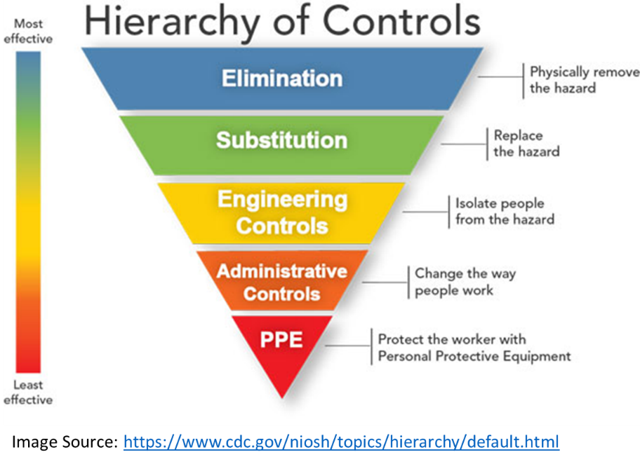Engineering Controls – Engineering controls are favored over administrative and personal protective equipment (PPE) for controlling existing worker exposures in the workplace because they are designed to remove the hazard at the source, before it comes in contact with the worker. Well-designed engineering controls can be highly effective in protecting workers and will typically be independent of worker interactions to provide this high level of protection. The initial cost of engineering controls can be higher than the cost of administrative controls or PPE, but over the longer term, operating costs are frequently lower, and in some instances, can provide a cost savings in other areas of the process.
3. Administrative Controls and PPE – Administrative controls and PPE are frequently used with existing processes where hazards are not particularly well controlled. Administrative controls and PPE programs may be relatively inexpensive to establish but, over the long term, can be very costly to sustain. These methods for protecting workers have also proven to be less effective than other measures, requiring significant effort by the affected worker.
   1. **Standard Operating Procedures**

In addition to the General Standard Operating Procedures detailed for all laboratories in Section 6.0 of this plan, laboratory/research-specific Standard Operating Procedures (SOPs) will be developed for select procedures identified by laboratory Hazard Assessments. Laboratory/research-specific SOPs and completed Hazard Assessments are located in the Chemical Hygiene section of the Trinity College EHS Webpage.

* 1. **Training**

Trinity College will provide laboratory personnel with information and training to ensure that they are apprised of the hazards of the chemicals present in their work area. The purpose of information and training is to ensure that all individuals at risk are adequately informed about the work being performed in the laboratory, associated hazards and actions to be taken to protect themselves during normal operations, as well as emergencies.

Please see Section 12 *Information and Training* for more details.

1. **Standard Operating Procedures for Working in Laboratories**
   1. **Proper Laboratory Attire**

When performing work with or near chemicals, laboratory personnel should cover all exposed parts of their body to prevent unnecessary chemical exposure. At a minimum, proper laboratory attire includes the following:

1. Lab coat or shirt with arm protection
2. Closed-toe shoes; and
3. Full leg coverage.
   1. **Personal Protective Equipment (PPE)**

When performing work with or near chemicals, laboratory personnel must adhere to the following baseline PPE requirements:

1. Proper laboratory attire (as described above);
2. Safety glasses/goggles; and
3. Appropriate gloves when handling chemicals (based on the type and hazards of the chemical).

Please note that additional PPE may be required based upon the specific hazards for the laboratory work and chemicals being used/handled. These are detailed in the laboratory/research-specific SOPs and completed Hazard Assessments which are located in the Chemical Hygiene section of the Trinity College EHS Webpage.

* 1. **General Safety Guidelines**

The following are standard safety rules which apply to all laboratories where hazardous chemicals are handled, used, and stored:

1. Laboratory personnel must not handle or perform work involving hazardous chemicals while alone in the lab.
   1. If personnel must work alone or during non-business hours, prior approval must be granted by the employee’s manager and the CHO. Appropriate safety and check-in procedures must be established and clearly understood before permission is granted.
2. Visitors are not allowed in labs unescorted.
3. Personnel must have and use appropriate lab attire and PPE.
4. It is important to always inspect personal protective apparel and equipment for integrity or proper function before use. Damaged/defective or unsanitary PPE must be replaced immediately and not be used.
5. Single-use, disposable protective equipment (such as latex/nitrile gloves) must not be re-used.
6. Smoking is prohibited inside of the laboratories or anywhere in the facility.
7. Eating, drinking, and gum chewing are prohibited in laboratories.
8. Horseplay and running is strictly prohibited.
9. Use only those chemicals for which you have the appropriate exposure controls (such as a chemical fume hood) and administrative programs/procedures (training, restricted access, etc.).Always read the safety data sheet (SDS) prior to using chemicals.
10. Laboratory equipment and chemicals are to be used for approved for lab purposes only.
11. Personnel must inspect equipment or apparatus for damage before adding a hazardous chemical. Do not use damaged equipment.
12. Malfunctioning laboratory equipment (such as a chemical fume hood) should be identified as "out of service" so that others will not inadvertently use it before repairs are made.
13. Always use adequate ventilation with chemicals. Operations using volatile or toxic substances should be performed in a chemical fume hood.
14. All secondary chemical containers must be labeled with appropriate identification and hazard information.
15. Lab personnel should not dispense more of a hazardous chemical than is needed for immediate use.
16. Avoid underestimation of risk: assume that all substances of unknown hazard or toxicity are hazardous and toxic.
17. Personnel are expected to report all incidents, accidents, and near misses which occur in the lab to their immediate supervisor and to the CHO (regardless of perceived severity).
    1. **Housekeeping**

The following housekeeping practices must be implemented at all times to reduce the likelihood of accident or chemical exposure:

1. All laboratory workers are responsible are required to keep their work area clean, orderly, and uncluttered, with chemicals and equipment being properly labeled and stored.
2. Wastes should be kept in the appropriate containers, in their designated satellite accumulation area(s) and labeled properly.
3. Laboratory fume hoods and work areas should be kept clean and free of debris at all times.
4. Work areas should be cleaned at the end of the experiment and at the end of the day.
5. Access to exits, emergency equipment, and utility controls must never be blocked.
6. Emergency exits must be kept unlocked from the inside.
7. Hallways should not be used as storage areas.
8. Do not allow trash to accumulate in any area; it can be a fire hazard and/or obstruct emergency equipment and egress routes.
9. Floors must be kept clean and dry at all times.

Laboratory staff should be considerate and aware of the housekeeping staff. Although housekeepers are provided hazard communication training on the basics pertaining to the presence of chemicals in the laboratory, they do not work with these chemicals and as such, must not be expected to have detailed knowledge and experience pertaining to laboratory chemical hazards. Therefore, in order to keep our housekeepers safe, lab personnel should make sure that:

1. All chemicals are placed in proper storage areas at the end of each workday.
2. All chemical containers are labeled with the identity of the chemical.
3. Any spills are promptly cleaned up and the spill material is disposed of properly.
4. No chemicals are stored in aisles, stairwells, desk, workbenches, floors, or hallways. All chemicals should be closed and stored properly.
   1. **Personal Hygiene**

Good personal hygiene practices are critical to preventing exposures to lab chemical hazards inside of the lab, but also to prevent laboratory workers from creating unintended exposures outside of the laboratory (for themselves or others) by inadvertently bringing contamination out of the lab. Lab personnel must always apply the following good hygiene practices:

1. Contact lenses and cosmetics must not be applied in the laboratory; generally speaking, hands should be kept away from the face, nose, and mouth as much as possible.
2. Mouth pipetting is strictly prohibited. Use a pipette bulb or other mechanical pipette filling device.
3. Never smell, inhale or taste a hazardous chemical.
4. Never wear lab coats or other personal protective equipment outside of the lab or in the office space
5. Proper laboratory attire, gloves, and PPE must be worn when handling chemicals.
6. Disposable gloves are for single use only and should not be re-used.
7. Re-usable chemical gloves should be washed after each use.
8. Hands must be washed when gloves are removed and prior to exiting the lab.
9. Keep clothing clean and change the clothing after the lab, especially if it has been soiled by chemicals.
   1. **Chemical Safety Information Sources**

Trinity College has established systems to provide chemical information to all laboratory personnel in laboratory settings, such as (but not limited to) the following:

1. Hazard Communication Labeling (Manufacturer Labels) – Laboratory personnel can identify basic chemical hazards by means of the product labeling on incoming chemical containers as required by the OSHA Hazard Communication Standard;
2. Hazard Communication Labeling (Secondary Container Labels) – Laboratory personnel are also instructed to label temporary containers with the chemical name and hazard type;
3. Laboratory Door Placards/Signs – Signs/placards posted at the entrance of each lab include a visual indicator of the type and degree of chemical hazards present.
4. Chemical Inventory and Safety Data Sheet (SDS) System - Trinity College uses the Vertére Inventory Manager system to track our inventory of lab chemicals and maintain electronic access to Safety Data Sheets. This web-based system can be accessed at <https://trincoll.vimenterprise.com/Login.aspx>.
   * Please note that login credentials are required. Please contact the CHO if you need access credentials.
   * Lab personnel are trained to use the chemical inventory and SDS system as part of annual training to the chemical hygiene plan.
   1. **Chemical Procurement & Screening**

Laboratory personnel should obtain prior approval to proceed with a laboratory procedure from a senior member of the lab staff and CHO when:

1. Working with particularly hazardous substances (see Appendix II-A for definitions);
2. Performing particularly hazardous procedures (i.e., potential for violent reaction); and/or
3. Working alone with particularly hazardous materials or hazardous procedures

The Chemical Hygiene Officer is available to assist laboratory staff in reviewing hazards associated with any procedure, equipment or chemical to be used in the laboratory to ensure that appropriate safety procedures are established.

In addition to the above, the following considerations must be applied when ordering chemicals:

1. How much of a particular chemical is needed for work to be performed.
   1. Lab personnel are encouraged to order only the minimum amount of hazardous material required and utilizing only the minimum amount during procedures;
2. The amount of storage space available.
   1. Including strict adherence to quantity limitations associated with applicable fire and hazardous materials codes;
3. The length of time the material will be required; and
4. Disposal considerations.
   1. **General Chemical Storage and Handling Guidelines**

There are many potential hazards associated with the storage and handling of laboratory chemicals. Understanding the properties of the chemicals and planning procedures by which they may be handled safely is one layer of control to help minimize these hazards. Simply storing chemicals alphabetically is not safe or prudent. Flammable, corrosive, explosive, and peroxide forming agents require special precautions. Storing incompatible chemicals together may have disastrous results.

1. Chemical Storage Guidelines
   1. All chemicals in the laboratory must have a designated storage area and should be returned after each use or at the end of each work shift, whichever occurs first.
   2. Storage of specific materials is discussed in Section 4.0.
   3. Chemicals should be stored according to their physical/chemical properties (e.g. buffers, acids, bases, flammables, etc.) and by compatibility.
   4. Storage trays or secondary containers should be used to minimize spillage of material if a container breaks or leaks.
   5. Avoid storing chemicals in the fume hood because containers and equipment can interfere with airflow, clutter the workspace, and increase the amount of material that could become involved in a hood fire.
   6. Avoid storing chemicals on bench tops.
   7. Avoid storing chemicals in direct sunlight or near a heat source.
   8. Physically separate incompatible chemicals using a secondary containment bins or trays, and or store at another designated location.
   9. All chemical containers must be properly labeled and stored in labeled storage areas.
   10. The label must include the full chemical name and associated hazards.
   11. Corrosive chemicals, oxidizers, and toxic chemicals should not be stored above eye level.
   12. Periodic inventories are conducted, and unneeded or expired items must be discarded.
2. Chemical Use Guidelines

Laboratory personnel must notify the CHO before conducting procedures that involve significant changes in:

1. Chemical amounts;
2. Chemical usage;
3. New equipment; or
4. Particularly hazardous substances.

General safety considerations include:

1. Experimental design;
2. Equipment design;
3. Workspace adequacy;
4. Development of an SOP and subsequent training (if necessary);
5. Work preparedness; and
6. Hazard assessment(s).

A hazard assessment will be conducted prior to the newly proposed work starting. The chemical hygiene officer and lab supervisors will assess the request and determine appropriate controls.

In addition to the General Standard Operating Procedures detailed for all laboratories in this section of the plan, laboratory/research-specific Standard Operating Procedures (SOPs) will be developed for select procedures identified by laboratory Hazard Assessments.

Laboratory/research-specific SOPs and completed Hazard Assessments are located in the Chemical Hygiene section of the Trinity College EHS Webpage.

1. Transporting Chemicals

The transportation of all chemicals must be done in a manner that minimizes the potential of a spill. Please utilize bottle carriers or other suitable secondary containers for larger volumes.

Carts that are approved for the safe transport of chemicals must not be overloaded and incompatible materials must be properly separated during transportation.

1. Receiving Chemicals

All chemicals that arrive must be unpackaged down to the primary container, immediately barcoded and entered into the inventory system, properly delivered to the designated scientist and stored.

1. Remove all bottles from boxes.
2. Flammables must be stored in flammable cabinets.
3. Remove chemicals from overpack containers and store appropriately.
4. Ensure proper inventory and storage of all chemicals after they have been unpacked.
5. Shipping Hazardous Chemicals
6. All chemicals Hazardous materials are regulated for transport by the Department of Transportation (DOT) and International Air Transport Association (IATA).
7. All employees who wish to ship material needs to work with the Operations Department and their DOT / IATA trained personnel.
   1. **Work in Chemical Fume Hoods**

The laboratory fume hood is one of the most important safety devices in the laboratory and can be highly effective in helping to prevent worker exposures to hazardous chemicals when used properly. The Chemical Hygiene Officer and Facilities Department are responsible for ensuring proper inspection, maintenance, and certification of the hoods.

Lab personnel working in fume hoods are required to adhere to the following procedure(s)/guidelines:

1. Chemicals are prohibited from being permanently stored in fume hoods;
2. Fume hoods are not to be used for evaporating chemicals;
3. Ensure the fume hood is on before working;
4. Understand the hazards of the chemical with which you are working;
5. Ensure air flow is in the adequate range by referencing the air flow meter;
6. Fume hoods must remain uncluttered;
7. Never place your head inside the fume hood;
8. Keep the sash height as low as possible when working inside the hood;
9. Ensure no materials are blocking the vents;
10. Work at least 6 inches inside of the hood to prevent exposure; and
11. Limit turbulence inside the fume hood by avoiding quick movements, gently moving equipment, and limiting traffic in the area.
    1. **Equipment containing radiation hazards, sealed sources or lasers**

The office of Environmental Health and Safety must be notified of any equipment that is being purchased or installed in a laboratory that contains radioactive hazards, sealed sources of radiation, or laser capabilities. These create special hazards that must be evaluated by the EHS office before being used on campus.

* 1. **Increase in Chemical Hazard or Biological Materials**

If a researcher is going to be conducting research that utilizes extremely hazardous chemicals or involves an increase in BioSafety Levels, written authorization must be submitted to the EHS office to investigate if the lab can accommodate the hazards associated. If the lab does have not have the adequate safety measures in place, the EHS office will work quickly to address the issues so work is not delayed.

Any and all laboratory work involving potentially hazardous biological materials must be planned and performed in accordance with the specific practices and procedures outlined in the Trinity College *Bloodborne Pathogens and Biosafety Plan*, which can be accessed via the Trinity College webpage: [<https://www.trincoll.edu/AboutTrinity/offices/facilities/EHS/Pages/Programs.aspx>].

1. **Safety and Emergency Equipment in the Laboratories**
   1. **General**
2. Lab areas are furnished with safety and emergency equipment as described in this section.
3. It is imperative that safety equipment is provided, maintained, used properly to ensure adequate exposure control and reduce risk.
4. Emergency equipment must never be blocked, removed, or otherwise tampered with.
5. Lab Managers, CHO and Facilities are responsible for maintaining, inspecting, resupplying, and testing equipment in the laboratories, unless otherwise specified elsewhere in this plan.
6. Lab personnel are encouraged to notify their supervisors, CHO, or Facilities if there are issues with any equipment in the labs.
   1. **Fume Hoods/Ventilation**

The laboratory fume hood is one of the most important safety devices in the laboratory. The ventilation system in the laboratory has been carefully balanced to ensure proper

airflow and comfortable working conditions. To prevent cross drafts, laboratory doors should be kept closed, whenever possible.

Laboratory fume hoods are evaluated and certified by a third-party contractor at least

annually. During these evaluations, average face velocity of the hood is measured, and the hood containment is evaluated using flow visualization.

* Hoods passing evaluation are labeled at an 18" sash height with a fume hood inspection sticker indicating the date of evaluation.
* Hoods failing evaluation are posted with a failure notification form, and the hood operator(s) is informed of the failure. Failed hoods are reported the Facilities Department for service and are reevaluated after service has been completed.
  1. **Safety Showers and Eyewash Facilities**

1. Safety Showers – should be provided where chemicals are handled. The showers provide first aid for chemical splashes.
2. Eyewash stations – are required in any lab where there is the potential for eye injury from exposure to hazardous chemicals.
3. All laboratories in which hazardous chemicals are handled should have ready access to plumbed, ANSI-approved eyewash stations and safety showers.
4. All lab personnel must ensure that safety showers and eyewash stations are free from obstruction.
5. All laboratory personnel must be aware of the nearest safety shower and eyewash station location and how to use the device.
6. Safety showers and eyewashes are inspected and tested at least monthly by a dedicated Facilities contractor.
7. Procedures for using the safety showers and eyewash stations are described in the Emergency Procedures Section
   1. **Spill Kits**
8. In the event of a hazardous material spill, supplies adequate to clean up, neutralize or otherwise mitigate the emergency are available in spill kits located throughout the labs.
9. Spill kits must contain a minimum of the following supplies:

* Spill pads or absorbent pads;
* Spill socks;
* Bags for the disposal of debris;
* Caution tape or other means to prevent entry and/or divert personnel away from the spill;
* Pair of nitrile gloves;
* Set of goggles; Dustpan and broom; and
* Incident Report Forms (blank).

1. Spill kits are routinely checked by the Lab managers during their regular walk-thoughs and by the CHO during formal lab inspections as detailed in Section 11.0 of this plan.
2. Procedures for managing chemical spills in labs are detailed in Section 9.0 of this plan.
   1. **Fire Extinguishers**
3. Portable fire extinguishers are necessary to rapidly suppress small fires in their incipient stage.
4. Only people trained to use a fire extinguisher should operate one. Basic fire extinguisher instruction is provided to lab personnel during annual lab safety training.
5. Never try to fight a large fire that is not small and easy to control.
6. Fire extinguishers are generally mounted either near an exit or at the back of the laboratory. There should be at least one extinguisher in each laboratory that is appropriate for the type/class of fire hazard(s) present in the lab. There are four types of fires, depending on the material that is burning:
   * Class A Fires: Fires in ordinary combustible materials, such as wood, cloth, paper, and many plastics.
   * Class B Fires: Fires involving flammable liquids, gases, and greases.
   * Class C Fires: Fires in energized electrical equipment. When the electrical equipment is deenergized, the fire may continue to burn as a Class A or B fire.
   * Class D Fires: Fires in combustible metals, such as magnesium, titanium, sodium, zirconium, and potassium.
7. All fire extinguishers are visually inspected at least monthly by a dedicated Facilities contractor.
8. All extinguishers are thoroughly inspected and serviced annually by a competent third party.
   1. **First Aid Kits**

First aid kits are located throughout our teaching and research laboratories. They are inspected yearly to ensure they are still fully stocked, and no material is past the expiration date.

1. **Emergency Procedures**
   1. **Chemical Spills - General**

It is important when planning laboratory work to anticipate the types of chemical spills that can occur and the necessary equipment (spill kits and personal protective equipment) are readily available to respond to a minor spill. It is also important to understand how to safely clean up minor spills of the chemicals used regularly.

A SDS contains special spill clean-up information and should also be

consulted. Chemical spills should only be cleaned up by trained, knowledgeable and experienced personnel.

If the spill is too large to handle, requires respiratory protection, is a threat to personnel, students or the public, or involves a highly toxic or reactive chemical, call for assistance immediately:

1. Campus Safety: (Emergency) 860-297-2222 (x2222 on-campus landline phone)
2. Chemical Hygiene Officer: 860-297-4250 (Office)
3. Triumvirate Environmental (Emergency Response Contractor) : 800-966-9282 (Emergency)
   1. **Chemical Spills – Minor Spill Events**

Trained lab personnel are permitted to engage in the clean-up of most minor spills without CHO direction or outside emergency response assistance by following the procedure below,

if they are comfortable doing so and fully understand the hazards of the spilled material and methods to protect themselves. However, if there are any concerns or questions about the ability to safely clean the spill, the CHO should be contacted.

The general procedure for minor spill events is as follows:

1. Warn others in the area. Alert them of the material spilled. React and respond with caution.

### If it is safe to do so, plan your cleanup; take into consideration the quantity, type, and location of the spill.

### Read the safety data sheet (SDS) for the chemical(s) involved.

### Don the appropriate personal protective equipment.

#### Contain the spill by placing spill pads and/or spill socks found in the spill kits around the material If you need more supplies, ask a coworker to get them. Do not leave spills unattended.

#### If there is broken glass or sharps involved in the spill, do not handle them directly. Use a dustpan and broom or tongs.

#### Work from perimeter inwards. Collect residue with scoop, dustpan, or cardboard. Ensure all spilled materials are fully absorbed and there is no remaining residue.

#### Place all contaminated debris, including absorbent, PPE and other spill materials in a compatible waste container. If there are too many materials, or they do not fit a waste profile for a given waste stream (i.e. lab trash, etc), please use heavy-duty plastic bags. All sharps must be disposed of in sharps containers; and

#### Properly dispose of heavy-duty plastic bags by labeling it with a hazardous waste label with the words “Spill Debris”. If said bag does not fit in a satellite accumulation area (SAA), please notify the lab manager and/or CHO.

### The incident must be immediately reported to the lab manager and to the CHO within 24 hours for review, incident investigation, and corrective/preventive action (as appropriate).

* 1. **Chemical Spills – Major (Emergency) Spill Events**

Major (Emergency) hazardous materials spills are categorized by uncontrollability and a direct threat to the health and safety of people or the environment.

Personnel who are not certified in responding to emergency spills are prohibited from attempting to respond, neutralize, absorb, or otherwise ‘treat’ an emergency spill and must summon emergency response immediately:

* Campus Safety: (Emergency) 860-297-2222 (x2222 on-campus landline phone)
* Chemical Hygiene Officer: 860-297-4250 (Office)
* Triumvirate Environmental (Emergency Response Contractor) : 800-966-9282 (Emergency).

Laboratory personnel must utilize the following procedure if a major (emergency) hazardous material spill occurs:

1. Warn others in the area; alert them of the material spilled. React and respond with caution.
2. Attend to any person that has been exposed to the material, utilizing emergency eye washes and emergency safety showers, if safe to do so. Do not attempt to help injured personnel if there is a possible threat to your health or safety.
3. Summon emergency response support noted above. If there is a life-threatening injury/illness or the is the potential for a fire/ explosion from the spill, dial 911 and proceed to evacuate by initiating the fire alarm).
4. Personnel are prohibited from returning to the area until cleared by emergency coordinators or emergency responders.
   1. **Hazardous Materials Exposures - Guidelines**

All chemical exposures must be taken seriously. Lab personnel must be familiar with these guidelines and procedures listed in the following sections when responding to chemical exposures.

1. General Guidelines

Lab personnel that witness or are involved in any chemical exposure, shall respond as follows:

* 1. Contact Campus Safety as well as CHO and provide as much information as possible.
  2. Make sure you have a copy of the Safety Data Sheet. Dial 911 if necessary (i.e. it is a medical emergency).
  3. Do not attempt to provide medical aid to an individual if the injury is the result of an emergency hazardous materials spill – doing so may endanger your life and safety.
  4. The person involved should never drive themselves to the emergency room or health care provider after chemical exposure – summon an ambulance or arrange for other transportation.
  5. The incident must be immediately reported to the lab manager and to the CHO within 24 hours for review, incident investigation, and corrective/preventive action (as appropriate).

1. Exposures to the Eyes/Face

In addition to the General Guidelines noted above:

1. Proceed to the closest eyewash or have someone guide you there;
2. Turn the flow of water on by pulling the unit out of the wall;
3. Open your eyelids with your thumb and index finger;
4. Begin flushing your eyes and continue to do so for at least 15 minutes; and
5. After flushing for 15 minutes, seek medical attention.
6. Exposures to the Body/Skin

In addition to the General Guidelines noted above:

1. Proceed to the closest safety shower or have someone guide you there;
2. If necessary, remove exposed clothing by cutting the fabric – pulling a shirt over your head can exacerbate exposure;
3. Turn the flow of water on by pulling down on the lever;
4. Continue to flush the exposed area for at least 15 minutes; and
   1. After flushing for 15 minutes, seek medical attention.
5. Chemical Ingestion, Inhalation, Absorption:

In addition to the General Guidelines noted above:

* 1. Immediately dial, or have someone dial, 911, and alert Chemical Hygiene Officer and Campus Safety.
  2. Contact the Poison Control Center (800- 222-1222) and have the safety data sheet readily available
  3. Follow instructions provided – responding to exposures will vary depending on the scenario and chemical(s) involved
  4. Provide copy of SDS for substance, if possible, to emergency responders.

1. Injection / Sharps Injury – If believed to be contaminated

In addition to the General Guidelines noted above:

* 1. Allow free bleeding
  2. Wash thoroughly with soap and water without scrubbing
  3. Cover with waterproof dressing
  4. Alert Chemical Hygiene Officer and Lab Supervisor.
  5. After cleaning and dressing, seek medical attention.
  6. **Medical Consultation**
     1. Laboratory personnel who work with hazardous chemicals will be provided the opportunity for medical attention, examination and follow-up by a competent physician if:
        1. An individual develops signs or symptoms associated with exposure to a hazardous chemical;
        2. Exposure monitoring reveals an exposure level routinely above the action level (or in the absence of an action level, the permissible exposure limit) for an OSHA regulated substance for which there are exposure monitoring and medical surveillance requirements; or
        3. Whenever an event takes place in the work area such as a spill, leak, explosion or other occurrence resulting in the likelihood of a hazardous exposure.
     2. The person who will be examined may visit Hartford Health Services or Hartford Hospital, 80 Seymour Street, Hartford, Ct. In either case, if necessary, they will be referred to a specialist.
     3. Injured or ill personnel should not be allowed to operate a motor vehicle, please contact Campus Safety (x2222) to arrange transportation.
     4. Information Provided to the Physician
        1. The identity of the hazardous chemical(s) to which laboratory personnel may have been exposed and the SDS;
        2. A description of the conditions under which the exposure occurred including quantitative exposure data, if available; and
        3. A description of the signs and symptoms of exposure that laboratory personnel are experiencing, if any.
     5. Physician’s Written Opinion – For examination or consultation required by OSHA’s Laboratory Standard, Trinity College shall obtain a written opinion from the examining physician which shall include the following:
        1. Recommendation for further medical follow-up;
        2. The results of the medical examination and any associated tests;
        3. Any medical condition which may be revealed in the course of the examination which may place laboratory personnel at increased risk as a result of exposure to a hazardous chemical found in the workplace; and
        4. A statement that the laboratory personnel have been informed by the physician of the results of the consultation or medical examination and any medical condition that may require further examination or treatment.
        5. The written opinion shall not reveal specific findings of diagnoses unrelated to occupational exposure.
        6. The medical report will be sent directly to Human Resources (x2272) who will pass the appropriate information along to those involved.
     6. Documentation – All memos, notes and reports related to a complaint of possible exposure must be maintained in a file for easy retrieval with a cross-reference in the employees personnel file.
     7. Notification – The employee shall be notified of the results from any medical examination. The employee shall also be made aware of any medical condition that might exist from overexposure to a chemical.

1. **Laboratory Waste Management**
   1. **Introduction**

Hazardous waste chemicals regulated by the Environmental Protection Agency and Connecticut Department of Environmental and Energy Protection must be collected, labeled, packaged and disposed of according to federal and state hazardous waste regulations. Hazardous waste is any solid, liquid, sludge or containerized gas that is discarded, has served its intended use, or is manufacturing byproduct, and exhibits any of the characteristics identified below:

* Flammable
* Corrosive
* Reactive
* Toxic

It is the responsibility of the waste generator to adhere to proper waste management and disposal policies. Hazardous waste should be collected in an appropriate container, labeled with all constituents, and transferred to one of the college’s three Main Accumulation Areas. That waste will be then handled for disposal by a third-party hazardous waste contractor.

The CHO should be notified if waste bottles are full and need to be removed from Satellite Accumulation Areas (SAA) and brought to the Main Accumulation Area (MAA). The CHO will do routine checks of the SAA’s to check for containers ready for disposal.

Complete details pertaining to Trinity College’s Hazardous Waste Management program can be found in the Trinity College *Hazardous Waste Management Compliance Plan*, which can be accessed via the Trinity College webpage: [<https://www.trincoll.edu/AboutTrinity/offices/facilities/EHS/Pages/Programs.aspx>].

* 1. **General Laboratory Waste Guidelines**

1. Any material that meets the criteria of a hazardous waste shall not be treated or otherwise changed to alter its characteristics as a hazardous waste.
2. Containers collecting waste deemed to be hazardous must be labeled with an approved hazardous waste label at the time the first drop is added to the collection container.
3. Empty containers of hazardous materials shall be rinsed three times before disposal. The first rinse shall be collected as hazardous waste; Empty containers of acutely hazardous wastes (p-listed) must be collected as hazardous waste or can be triple rinsed with all three rinses being collected as hazardous waste.
4. Dispose of all waste in designated, labeled containers. Any questions about proper disposal methods should be directed first to the designated laboratory manager and Chemical Hygiene Officer.
5. Do not combine different waste streams (i.e. biohazardous and hazardous or incompatible hazardous materials).
6. Do not overfill containers.
7. Manage common laboratory waste (uncontaminated gloves, paper towels, etc.) in the general trash.
8. Broken glass and sharp objects shall never be disposed in general trash receptacles, autoclave bags or recycling bins.
9. Glass bottles (not eligible for recycling) shall be triple rinsed with water and their labels defaced before discarding.
10. Glass bottles or broken glass must be disposed of in cardboard “Deposit Glass Here’ boxes. These boxes are available in each academic laboratory. Seal the top of the box closed with tape when it is full and label it “trash”.
    1. **Guidelines for Storage and Handling of Hazardous Waste**
11. All hazardous waste generated at Trinity College must be accumulated and stored in a SAA before being transferred to the MAA.
12. The SAA’s are marked by a sign defining the SAA. The area is used for the accumulation of waste generated at the point of generation.
13. All SAA waste containers must be labeled with SAA labels or the words “Hazardous Waste” with the full chemical name and hazard class (e.g. flammable).
14. When an SAA waste container becomes full, date the container with the ‘full date’ and inform the laboratory manager.
15. SAA containers can remain in the SAA indefinitely or until they become full. Full containers must be moved into the MAA within three days of the full date.
16. All containers must be closed and sealed when not in use.
17. Waste must be stored in containers compatible with the constituents of the waste.
18. Secondary containment bins must be used to prevent mixing of incompatible waste streams.
    1. **Biological Waste**

Biological waste is characterized as waste which may pose a health hazard. Biological waste consists of contaminated animal carcasses, needles and syringes, cell culture wastes and any biologically contaminated laboratory debris. All biohazardous waste must be collected, managed, stored, and disposed of in accordance with the specific practices and procedures outlined in the Trinity College *Bloodborne Pathogens and Biosafety Plan*, which can be accessed via the Trinity College webpage: [<https://www.trincoll.edu/AboutTrinity/offices/facilities/EHS/Pages/Programs.aspx>].

* 1. **Sharps Disposal – General Guidelines**

All Sharps waste must be collected, managed, stored, and disposed of in accordance with the specific practices and procedures outlined in the Trinity College *Bloodborne Pathogens and Biosafety Plan*, which can be accessed via the Trinity College webpage: [<https://www.trincoll.edu/AboutTrinity/offices/facilities/EHS/Pages/Programs.aspx>].

1. **Information and Training**
   1. **General**

Trinity College will provide laboratory personnel with information and training to ensure that they are apprised of the hazards of the chemicals present in their work area. The purpose of information and training is to ensure that all individuals at risk are adequately informed about the work being performed in the laboratory, associated hazards and actions to be taken toprotect themselves during normal operations, as well as emergencies.

All laboratory personnel receive an initial laboratory safety training as well as reoccurring annual trainings.

* 1. **Training Program Overview**

The lab safety training program covers the following topics:

1. Methods and observations that may be used to detect the presence or release of a hazardous chemical.
2. Determining physical and health hazards of chemicals in the work area.
3. Measures laboratory personnel can take to protect themselves from these hazards.
4. Specific procedures to provide protection, including engineering controls, work practices and personal protective equipment.
5. Emergency procedures.
6. Explanation of Material Safety Data Sheets and container labeling.
7. How to obtain and use chemical hazard information.
8. Basic instruction on fire extinguisher use for incipient stage fires.
9. Review of the components and implementation of the Chemical Hygiene Plan
10. **Inspections and Plan Evaluation**
    1. **Laboratory Inspections**

In order to evaluate the implementation status and effectiveness of the Chemical Hygiene Plan, the Laboratory Safety Committee and Chemical Hygiene Officers, will perform laboratory inspections at once per semester to review laboratory safety conditions, practices, and to check safety equipment.

* 1. **Plan Review and Update**

The Chemical Hygiene Officer and Chemical Hygiene Committee will review annually and, if necessary, update this Chemical Hygiene Plan. Changes to the plan will be based on regulatory changes, changes in college-wide safety policies and practices, feedback from laboratory personnel and results of laboratory inspections.

1. **Records and Retention**
   1. **Records to be Maintained**

Trinity College will maintain accurate and complete records concerning the following:

1. Medical examination and consultation;
2. Exposure monitoring;
3. Training; Fume hood evaluations; and
4. Laboratory inspections.
   1. **Records Retention**
5. Medical examination and consultation records, including test results and physician’s written opinions, are to be maintained in an appropriate confidential manner by Human Resources. These records are to be kept, transferred and made available for at least the duration of the worker’s employment plus thirty years. These records shall be maintained in accordance with 29 CFR 1910.1020 “Access to Employee Exposure and Medical Records”.
6. Employee exposure records, including sampling results, MSDSs or other chemical-specific information, are to be maintained by the specific Departments. These records are to be kept, transferred and made available for at least 30 years. These records shall be maintained in accordance with 29 CFR 1910.1020. Exposure monitoring records generated by EH&S will be also maintained in the EH&S central files.
7. Training records are maintained in the laboratory’s department files. Records of training conducted by EH&S will be maintained by EH&S.
8. Fume hood certification records for certifications conducted by department vendors are maintained in the laboratory’s department files and updated annually. These records are maintained until the next certification is performed. Records of fume hood evaluations performed by EH&S are maintained by EH&S.
9. Laboratory inspection records are maintained in the EH&S Central Files. These records are maintained for at least two years.

**13.0 Associated Documents**

* Trinity College *Bloodborne Pathogens and Biosafety Plan*
* Trinity College *Hazardous Waste Management Compliance Plan*

**14.0 Document Review and Revision History**

|  |  |  |  |
| --- | --- | --- | --- |
| **Date** | **Revision No.** | **Description** | **Author/Reviewer** |
| 10/12/2020 | 1 | Updated Employee and CHP committee members | Kyle Coughlin |
|  |  |  |  |
|  |  |  |  |
|  |  |  |  |
|  |  |  |  |
|  |  |  |  |
|  |  |  |  |
|  |  |  |  |
|  |  |  |  |
|  |  |  |  |
|  |  |  |  |
|  |  |  |  |